

**6th Grade Supply List** ***(all subjects)***

**____☺ $10.00 (Cash only) to purchase necessary supplies throughout the year**

**____☺ 1- 13 pocket letter size mesh/fabric or plastic accordion folder with closure**

**____☺ 1- green spiral 3 subject notebook (perforated pages) (*science*)**

**____☺ 1- black spiral 1 subject notebook (perforated pages) *(Spanish)***

**____☺ 2- purple spiral 1 subject notebook (perforated pages) *(social studies)***

**____☺ 1- red, sewn composition notebook *(math)***

**____☺ 1- large, yellow, sewn composition notebook for notes and homework *(religion)***

____**☺ 1- 2 pocket folder for notes and homework (*music*)**

**____☺ 1- blue, spiral, 3-subject notebook that includes folders *(language arts)***

**____☺ 1- scientific calculator eg. TI-30 or similar model (not a graphing calculator)**

***____*☺ 1- pack of graph paper (not a pad) (*math*)**

**____☺ 1- pack of 100 3 x 5 lined index cards (*language arts*)**

**____☺ 2- dozen Ticonderoga pencils *(homeroom)***

**____☺ 2- pack of 10 or 12 blue or black pens, NOT erasable (*homeroom*)**

**____☺ 3- brown paper grocery bags for book covers**

**____☺ earbuds for use with computers**

**____☺ Chrome book case--Solid Black Evecase 11.6 Neoprene Padded Slim**

**Sleeve with colored trim (available from Amazon)**

**A soft pencil case with the following items:**

**____☺ 4 highlighters- multiple colors including yellow**

**____☺ No. 2 pencils**

**____☺ Black or blue ballpoint pens**

**____☺ Red pen (for editing and correcting)**

**____☺ Red pencil**

**____☺ Eraser**

**____☺ Manual pencil sharpener**

**____☺ 1- 6 inch standard/metric ruler**



**7th Grade Supply Lists (All Subjects)**

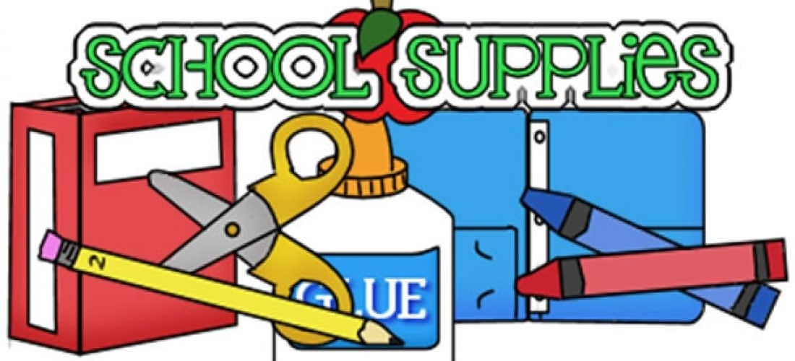

**7th Grade Supply List (All Subjects)**

**____☺ $10.00 (Cash only) to purchase necessary supplies throughout the year**

**____☺ 1- 13 pocket letter size mesh/fabric or plastic accordion folder with closure**

**____☺ 1- green spiral 3-subject notebooks (perforated pages) *(science)***

**____☺ 2- purple spiral 1 subject notebook (perforated pages) *(social studies)***

**____☺ 1- black spiral 1 subject notebook (perforated pages) *(Spanish)***

**____☺ 1- blue, spiral, 3-subject notebook that includes folders *(language arts)***

**____☺ 1- yellow spiral 1-subject notebook (perforated pages) *(religion)***

**____☺ 1- red, sewn composition notebook *(math)***

**____☺ 1- 2 pocket folder for notes and homework (*music*)**

**____☺ 1- scientific calculator eg. TI-30 or similar model (not a graphing calculator)**

**____☺ 1- pack of 100 3 x 5 lined index cards (*language arts*)**

**____☺ 2- pack of 10 or 12 blue or black pens, NOT erasable (*homeroom*)**

**____☺ 1- dozen Ticonderoga pencils *(homeroom)***

**____☺ 3- brown paper grocery bags for book covers**

**____☺ Earbuds for using with computers**

**____☺ Chrome book case--Solid Black Evecase 11.6 Neoprene Padded Slim**

**Sleeve with colored trim (available from Amazon)**

**A soft pencil case with the following items:**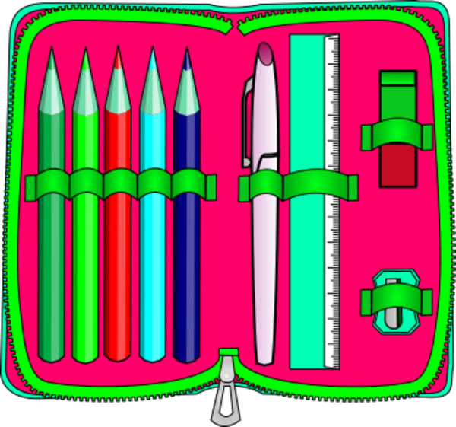

**____☺ 4 highlighters - multiple colors including yellow**

**____☺ No. 2 pencils**

**____☺ Black or blue ballpoint pens**

**____☺ Red pen (for editing and correcting)**

**____☺ Red pencil**

**____☺ Eraser**

**____☺ Manual pencil sharpener**

**____☺ 1- 6 inch standard/metric ruler**



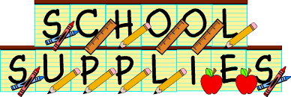

**8th Grade Supply List (All Subjects)**

**____☺ $10.00 (Cash only) to purchase necessary supplies throughout the year**

**____☺ 1- 13 pocket letter size mesh/fabric or plastic accordion folder with closure**

**____☺ 1- green spiral 3-subject notebooks (perforated pages) *(science)***

**____☺ 2- binder with loose purple spiral 1 subject notebook (perforated pages) *(social***

***studies)***

**____☺ 1- black spiral 1 subject notebook (perforated pages) *(Spanish)***

**____☺ 1- blue, spiral, 3-subject notebook that includes folders *(language arts)***

**____☺ 1- yellow, spiral 1-subject notebook (perforated pages) *(religion)***

**____☺ 1- 1 inch binder with loose leaf paper, graph paper and dividers *(math)***

**____☺ 1- 2 pocket folder for notes and homework (*music*)**

**____☺ 1- graphing calculator (MUST be TI-83, TI-83 Plus or TI-84) is required for**

**all 8th grade math classes. See math teacher’s webpage for more calculator**

**information.**

**____☺ 1- pack of COLLEGE ruled loose-leaf paper (language arts)**

**____☺ 1- pack of SMALL *Post Its* (multiple color, 1.5” x 2”) *(language arts)***

**____☺ 2- pack of 10 or 12 blue or black pens, NOT erasable (*homeroom*)**

**____☺ 2- dozen Ticonderoga pencils *(homeroom)***

**____☺ 3- brown paper grocery bags for book covers - please leave at home**

**____☺ Earbuds for using with computers**

**____☺ Chrome book case--Solid Black Evecase 11.6 Neoprene Padded Slim**

**Sleeve with colored trim (available from Amazon)**

**A soft pencil case with the following items:**

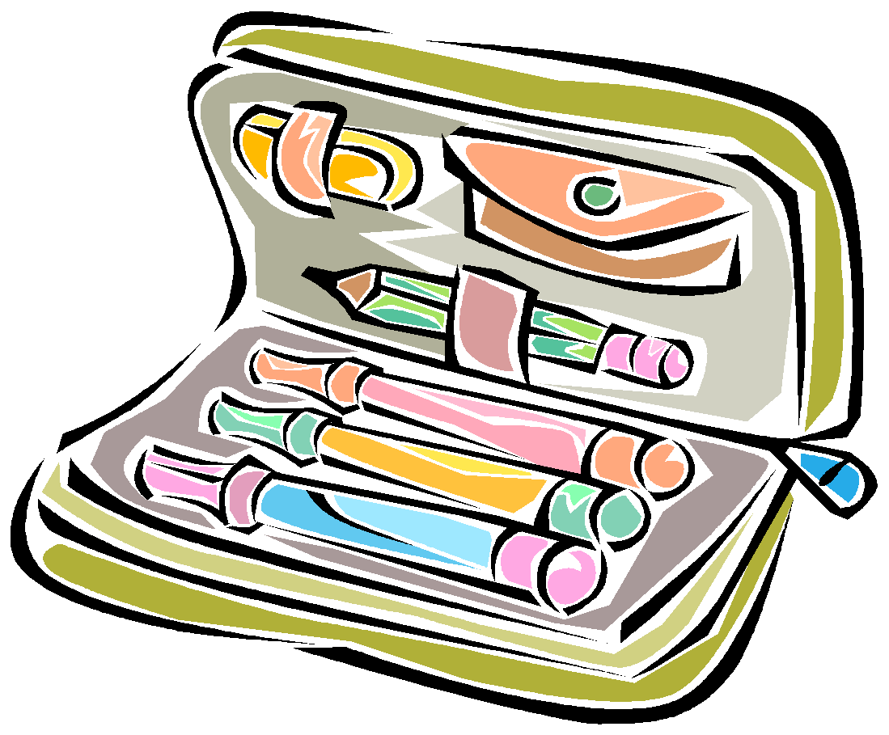

**____☺ 4 highlighters- multiple colors including yellow**

**____☺ No. 2 pencils**

**____☺ Black or blue ballpoint pens**

**____☺ Red pen (for editing and correcting)**

**____☺ Red pencil**

**____☺ Eraser**

**____☺ manual pencil sharpener**

**____☺ 1- 6 inch standard/metric ruler**

